First Challenge
- Launch oneEC2 instanceusingAmazon Linux 2.
- InstallDocker.
- InstallJenkins.
- InstallApache.
- InstallNginx.
- InstallApache Tomcat.
Everything needs to be setup and running on the same EC2.
Launch oneEC2 instance using Amazon Linux 2.
Step 1: Sign in to AWS Console
- Go to https://console.aws.amazon.com and sign in with your IAM user or root account.
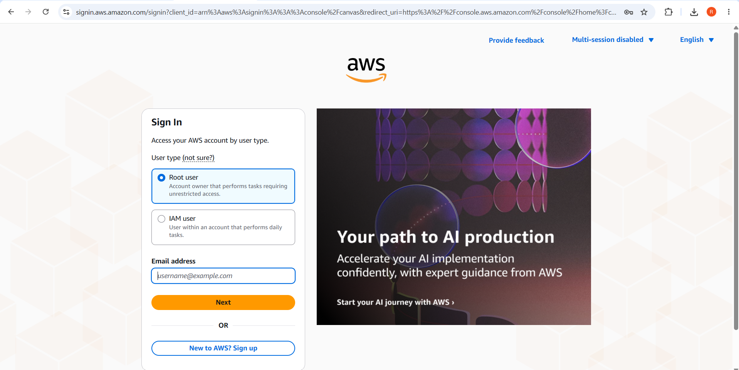

Step 2: Open the EC2 Dashboard
- In the search bar at the top, type EC2 and click on the EC2 service.
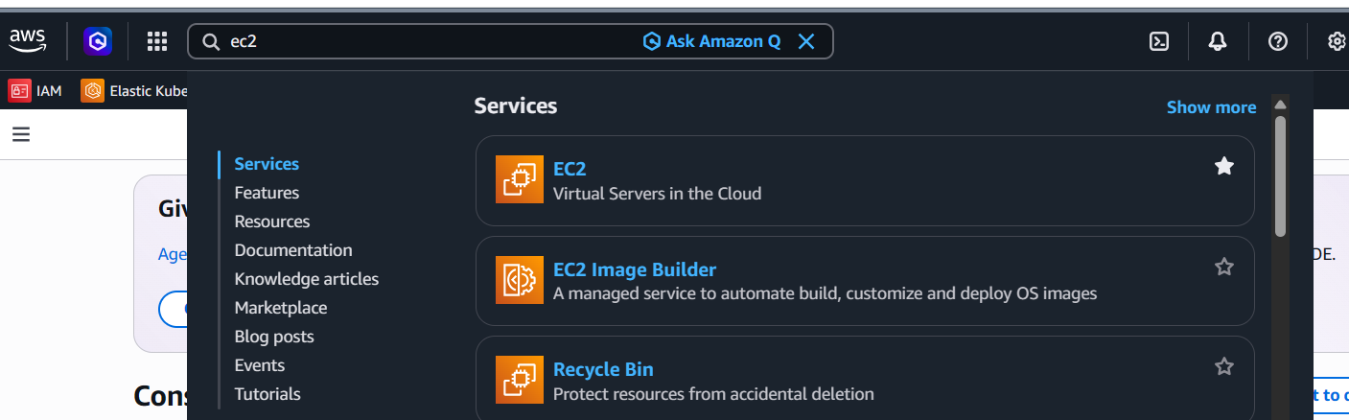
- On the EC2 Dashboard, click the orange Launch Instance button.
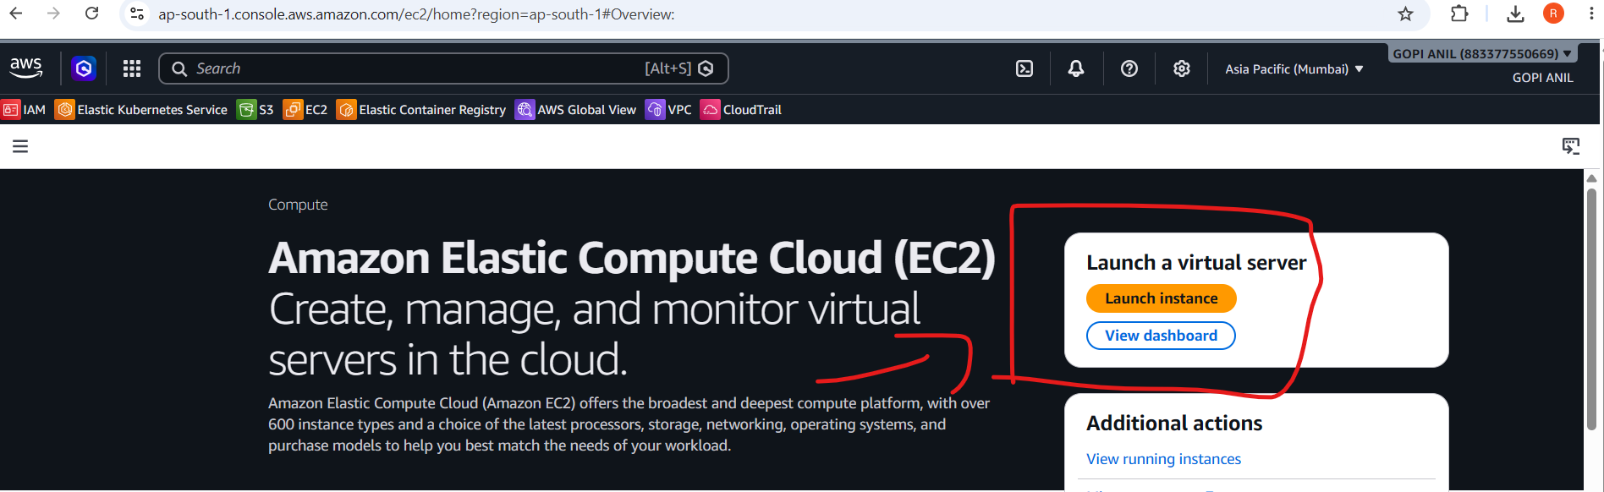
Step 3: Name the Instance
- Under Name and tags, enter a name for your instance (e.g., first-challenge-server).
- This becomes the value of the Name tag, shown in the instance list — helpful when you have multiple instances.
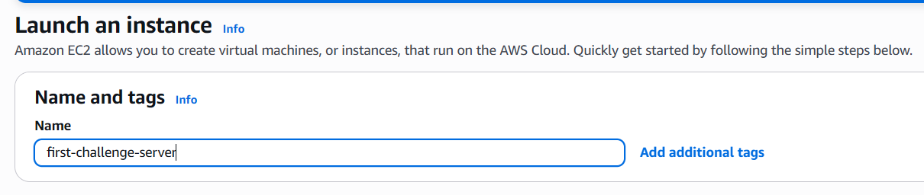
Step 4: Choose the Amazon Machine Image (AMI)
- Under Application and OS Images (Amazon Machine Image), click the Quick Start tab.
- Select Amazon Linux.
- In the dropdown, make sure it shows Amazon Linux 2 AMI (HVM), SSD Volume Type — not Amazon Linux 2023 (a newer version with different package commands).
- Confirm the architecture is 64-bit (x86) unless you specifically need ARM (Graviton).
- This AMI is Free Tier eligible.
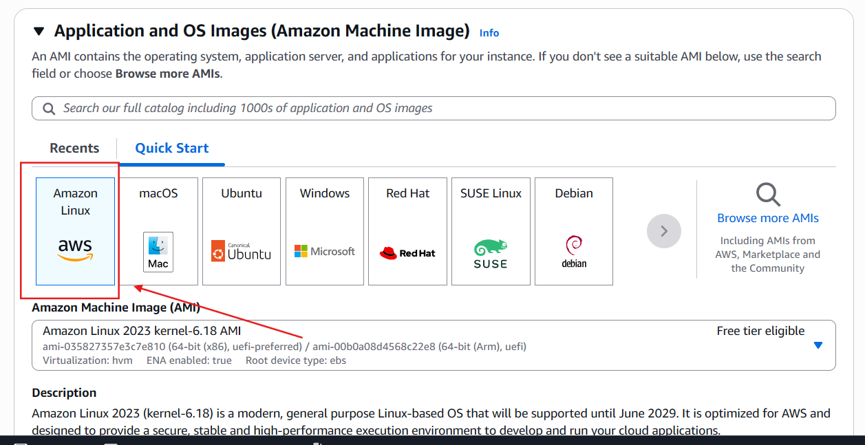
Step 5: Choose an Instance Type
- Under Instance type, select t3.micro (2 vCPU, 1 GiB RAM) — Free Tier eligible, good for basic testing.
- Since this instance will run Docker, Jenkins, Apache, Nginx, and Tomcat together, consider c7i-flex.large (2 vCPU, 4 GiB RAM) if available/affordable, since 1 GiB RAM can get tight with five services running.
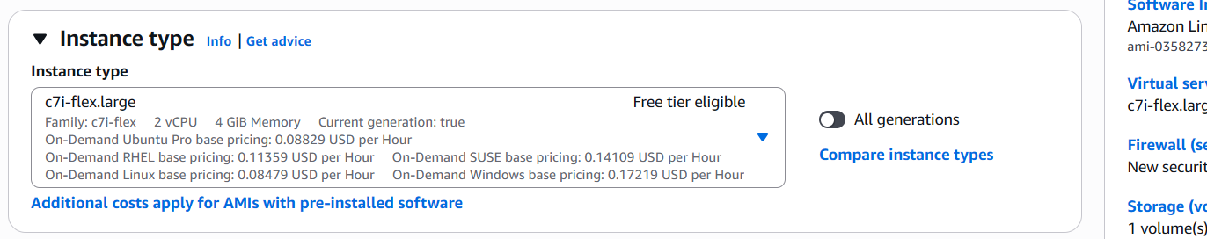
Step 6: Create or Select a Key Pair
- Under Key pair (login), click Create new key pair (if you don't already have one).
- Give it a name (e.g., my-ec2-key).
- Key pair type: RSA.
- Private key file format: .pem (for OpenSSH/Linux/Mac) or .ppk (for PuTTY on Windows).
- Click Create key pair — this automatically downloads the private key file to your computer.
- Important: This file is downloaded only once. Store it safely; you cannot re-download it later. Without it, you cannot SSH into the instance.
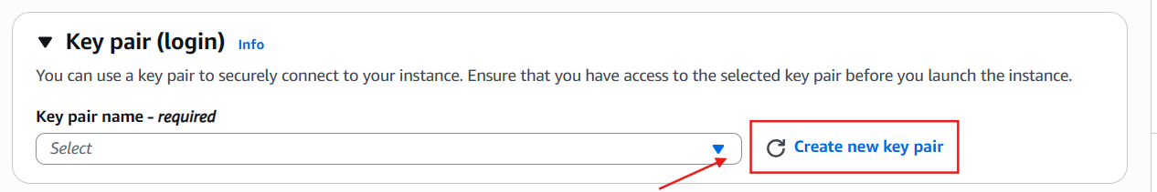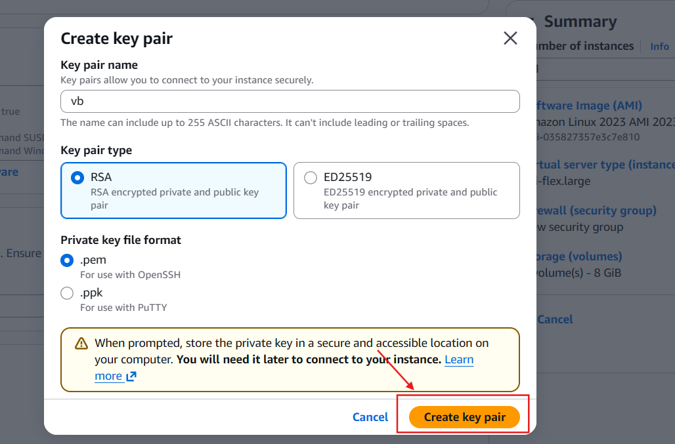
Step 7: Configure Network Settings
- Under Network settings, click Edit to customize.
- VPC: leave as default unless you have a specific VPC.
- Subnet: default is fine (or choose a specific Availability Zone).
- Auto-assign public IP: set to Enable — this is required so you can reach the instance over the internet via SSH and HTTP.
- Firewall (security groups): choose Create security group.
  - Give it a name/description (e.g., challenge-sg).
  - By default, AWS adds a rule allowing SSH (port 22) from My IP or Anywhere (0.0.0.0/0) — for security, prefer My IP.
  - Click Add security group rule to add more inbound rules as needed later (HTTP 80, custom ports for Jenkins/Tomcat, etc.) — you can also add these after launch by editing the security group.
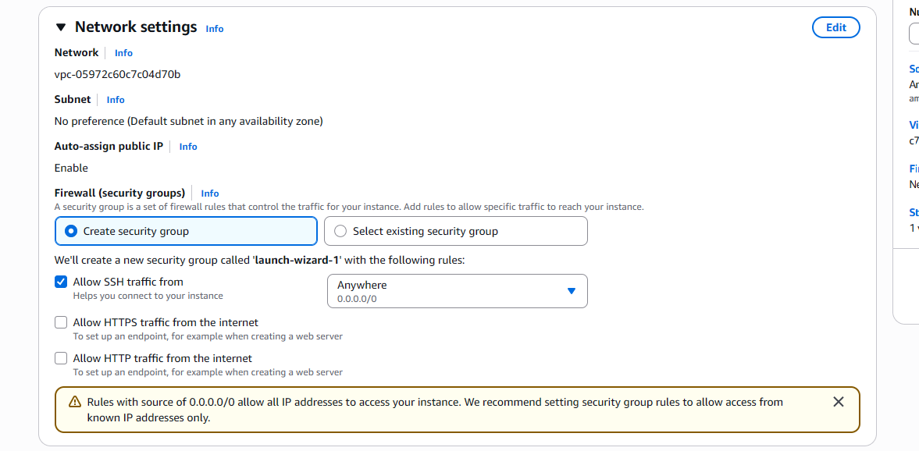
Step 8: Configure Storage
- Under Configure storage, the default is 8 GiB gp3 (General Purpose SSD).
- Increase this to 20–30 GiB if you plan to install multiple services (Docker images, Jenkins, Tomcat all consume disk space) — 8 GiB fills up quickly.
- Leave volume type as gp3 (better performance/cost than gp2).
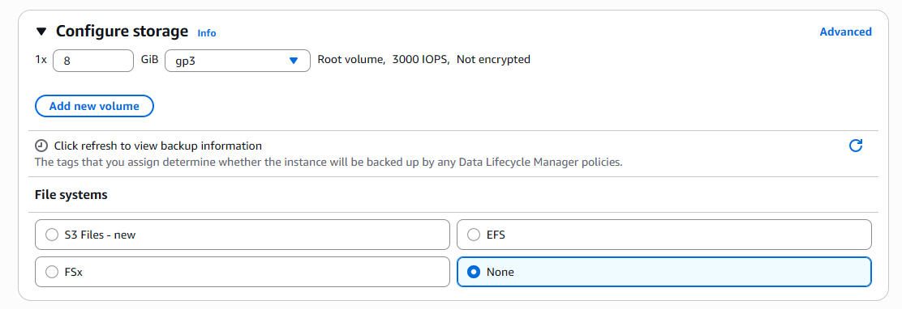
Step 9: Review and Launch
- Under Summary (right-hand panel), review:
  - Number of instances: 1
  - Software Image (AMI): Amazon Linux 2
  - Instance type
  - Key pair name
  - Storage size
- Click the orange Launch instance button.
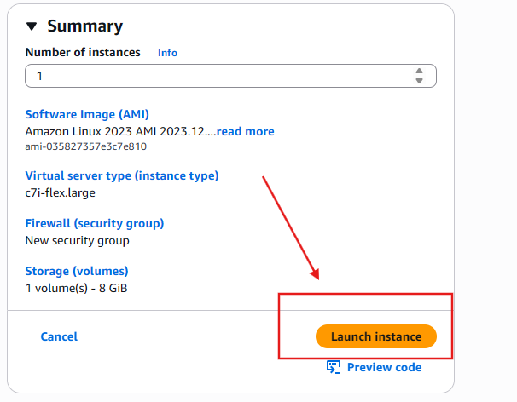
Step 10: Confirm Launch
- You'll see a green success banner: "Successfully initiated launch of instance."
- Click the instance ID link (or go to Instances in the left sidebar) to view your new instance.
- Wait for:
  - Instance state → Running
  - Status check → 2/2 checks passed (this can take 1–2 minutes)
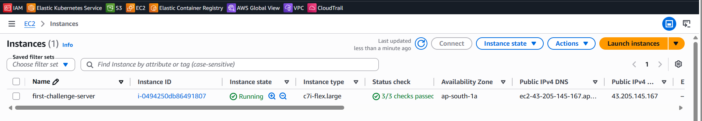

Step 11: Note Down Connection Details
- Select the instance and check the Details tab for:
  - Public IPv4 address
  - Public IPv4 DNS
- You'll need these to SSH in and to access any web services later.
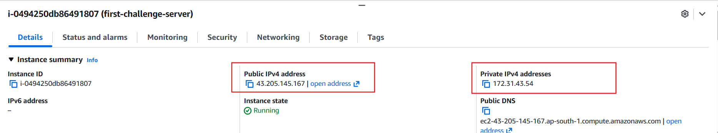
Step 12: Connect via SSH
On your local machine (Linux/Mac terminal, or Windows using WSL/Git Bash/PuTTY):
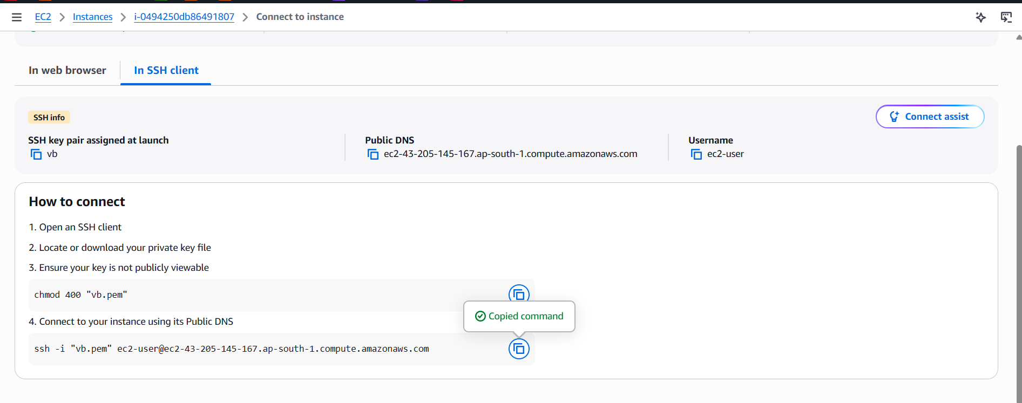
- chmod 400 restricts permissions on the key file — SSH refuses to use a key that's too open.
- The default username for Amazon Linux 2 is ec2-user (not root or ubuntu).
- On first connection, type yes when prompted to trust the host's fingerprint.
- A successful login shows the Amazon Linux welcome banner and a shell prompt like [ec2-user@ip-xxx-xx-xx-xx ~]$.
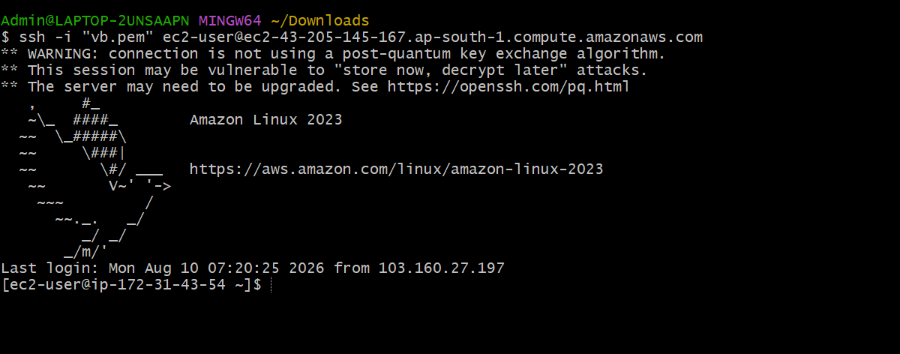
Install Docker.
Step 1: Connect to the EC2 Instance
- Open a terminal and SSH into your running Amazon Linux 2 instance:
ssh -i my-ec2-key.pem ec2-user@<PUBLIC_IP>
- Confirm you're logged in as ec2-user before proceeding.
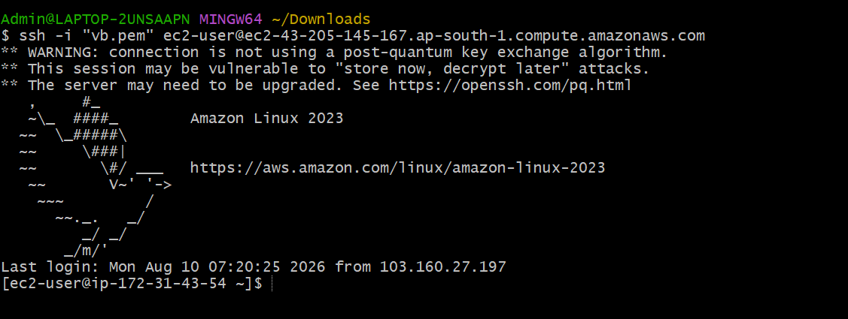
Step 2: Update System Packages
- Refresh the package index and update existing packages to the latest available versions:
sudo yum update -y
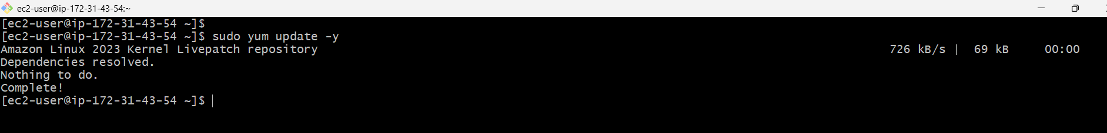
- This ensures Docker installs cleanly without conflicting with outdated packages. It may take a minute or two to complete.
Step 3: Install Docker
- Amazon Linux 2 ships Docker through the amazon-linux-extras repository rather than the default yum repo:
sudo dnf install docker -y
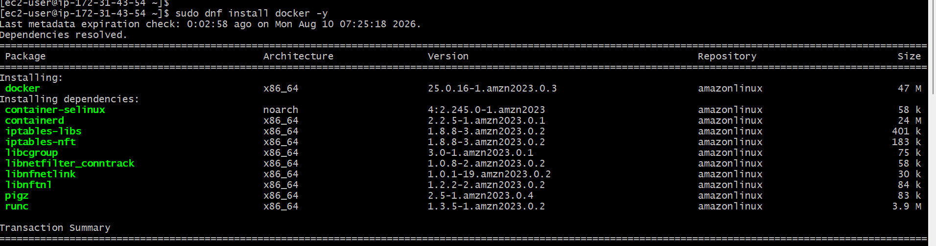
- This downloads and installs the Docker Engine package along with its dependencies.

Step 4: Start the Docker Service
- Start the Docker daemon:
sudo systemctl start docker
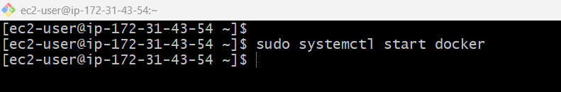
- Enable Docker to start automatically on every system boot:
sudo systemctl enable docker
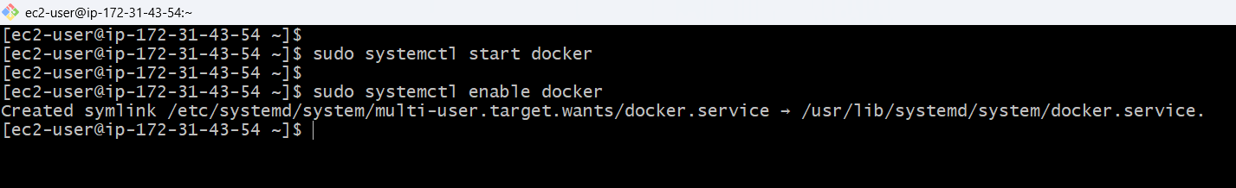
Step 5: Allow ec2-user to Run Docker Without sudo
- By default, only root can run Docker commands. Add ec2-user to the docker group so you don't need sudo for every command:
sudo usermod -aG docker ec2-user
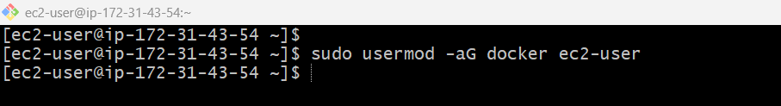
- This group membership only takes effect on a fresh login session. Either:
  - Log out and SSH back in, or
  - Run: newgrp docker (applies the group change to the current shell)
Step 6: Verify the Installation
- Check the installed Docker version:
docker –version
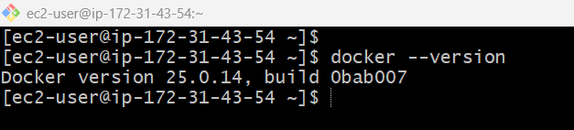
- Check that the Docker service is active and running:
sudo systemctl status docker
- Look for Active: active (running) in green text in the output.
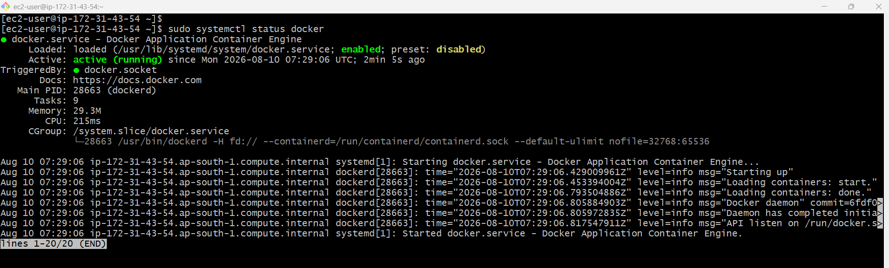
Install Jenkins.

Step 1: Connect to the EC2 Instance
- SSH into your running Amazon Linux 2 instance:
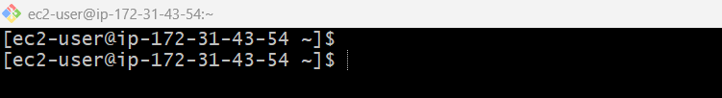
Step 2: Install Java
- Jenkins is a Java application and requires a Java Runtime Environment (JRE/JDK) to run. Current Jenkins LTS releases support Java 11 or Java 21 — Java 21 is recommended:
sudo dnf install -y java-21-amazon-corretto-devel
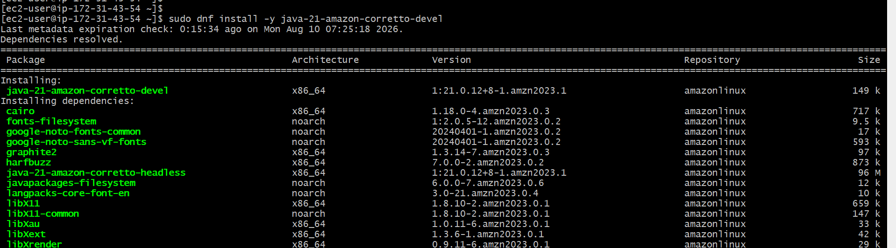
Verify Java installed correctly:
java -version
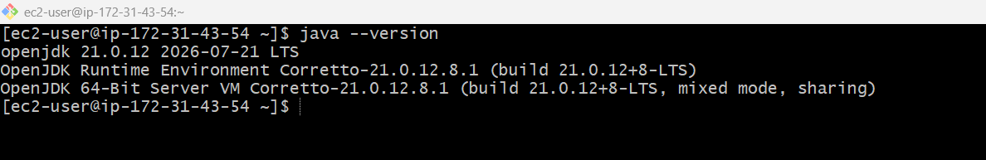
Step 3: Add the Jenkins Repository
sudo wget -O /etc/yum.repos.d/jenkins.repo \
https://pkg.jenkins.io/redhat-stable/jenkins.repo

sudo rpm --import https://pkg.jenkins.io/redhat-stable/jenkins.io-2026.key
sudo dnf install jenkins -y
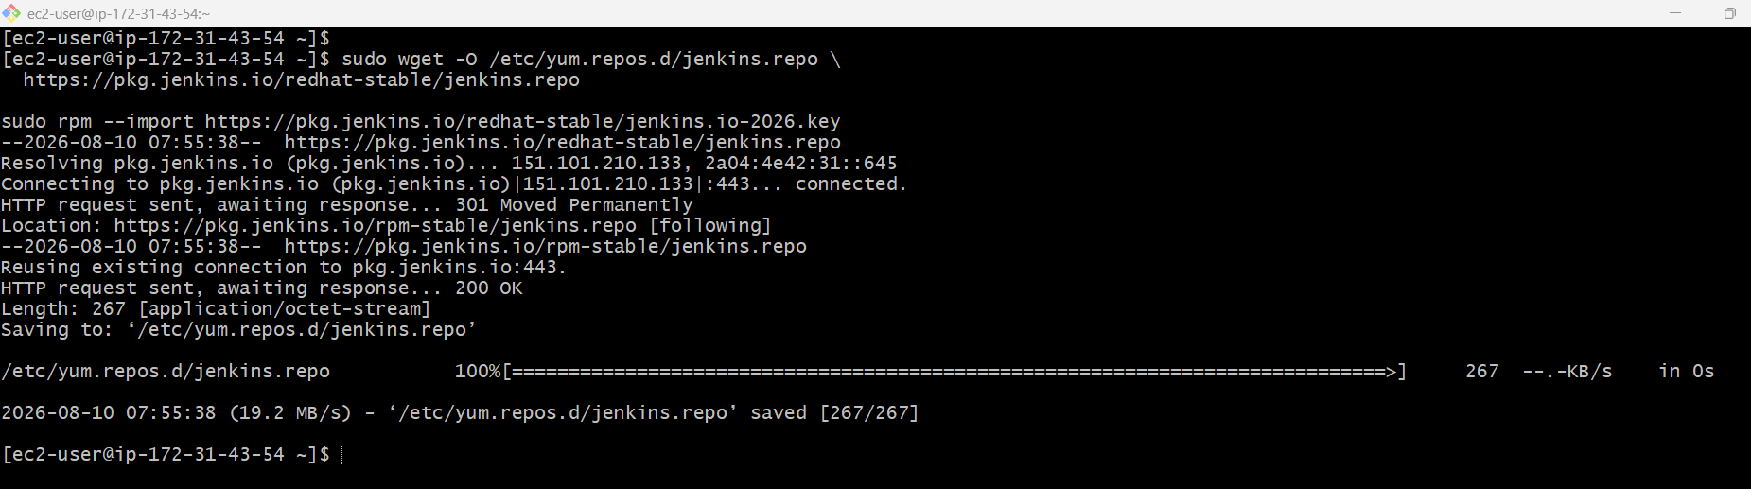
Step 5: Start and Enable the Jenkins Service
- Start Jenkins:
sudo systemctl start Jenkins
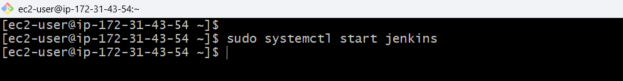
- Enable Jenkins to start automatically on system boot:
sudo systemctl enable Jenkins
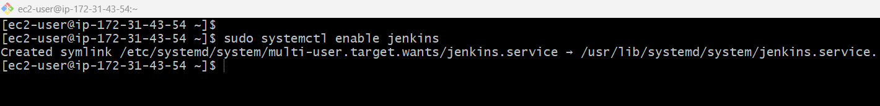
- Check the service status:
sudo systemctl status Jenkins
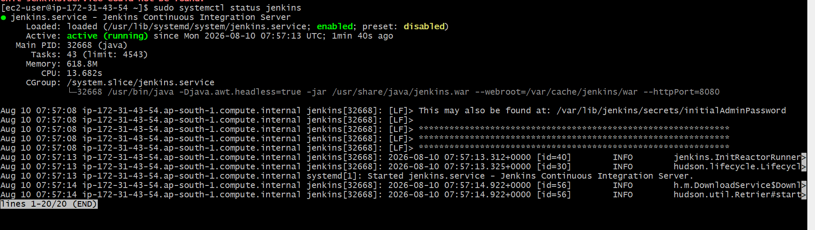
- Look for Active: active (running) in the output.
Step 6: Handle the Port Conflict (Important)
- Jenkins listens on port 8080 by default. If Apache Tomcat will also run on this same EC2 instance, it also defaults to 8080 — one of the two must be moved.
- Recommended: change Jenkins to port 8081, leaving 8080 for Tomcat:
sudo mkdir -p /etc/systemd/system/jenkins.service.d

sudo tee /etc/systemd/system/jenkins.service.d/override.conf > /dev/null <<'EOF'
[Service]
Environment="JENKINS_PORT=8081"
EOF

sudo systemctl daemon-reload
sudo systemctl restart Jenkins
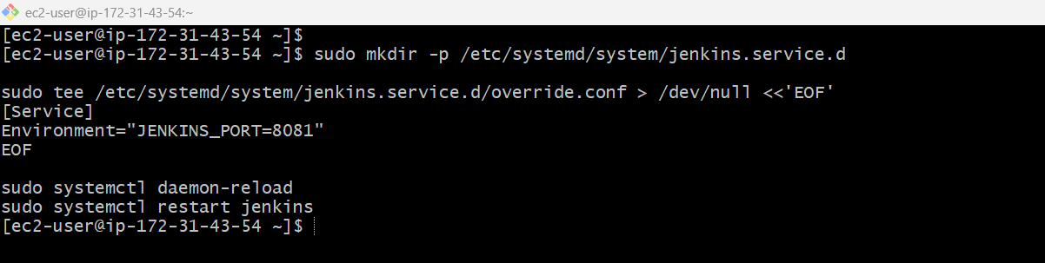
Step 7: Open the Required Port in the Security Group
- In the AWS Console, go to EC2 → Security Groups → select your instance's security group.
- Edit inbound rules and add:
  - Type: Custom TCP, Port: 8081 (or 8080 if you didn't change it), Source: your IP or 0.0.0.0/0
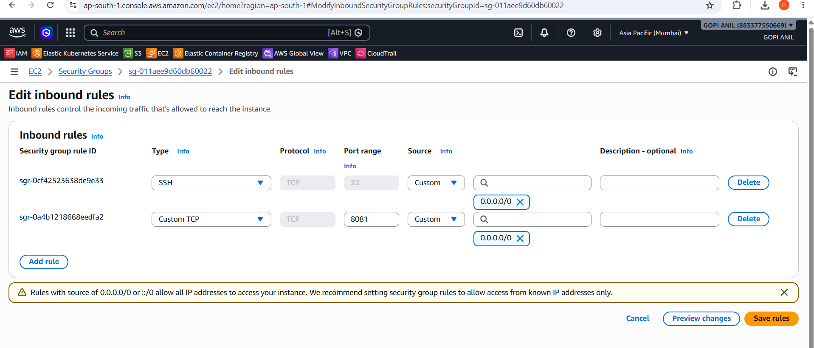
Step 8: Access Jenkins and Complete Initial Setup
- Open a browser and go to:
http://<PUBLIC_IP>:8081
- Jenkins will show an Unlock Jenkins screen asking for an initial admin password. Retrieve it on the server:
sudo cat /var/lib/jenkins/secrets/initialAdminPassword
- Copy the password into the browser and click Continue.
- On the next screen, click Install suggested plugins and wait for the setup to finish.
- Create your first admin user (username, password, name, email) when prompted.
- Confirm the Jenkins URL on the final setup screen and click Save and Finish, then Start using Jenkins.
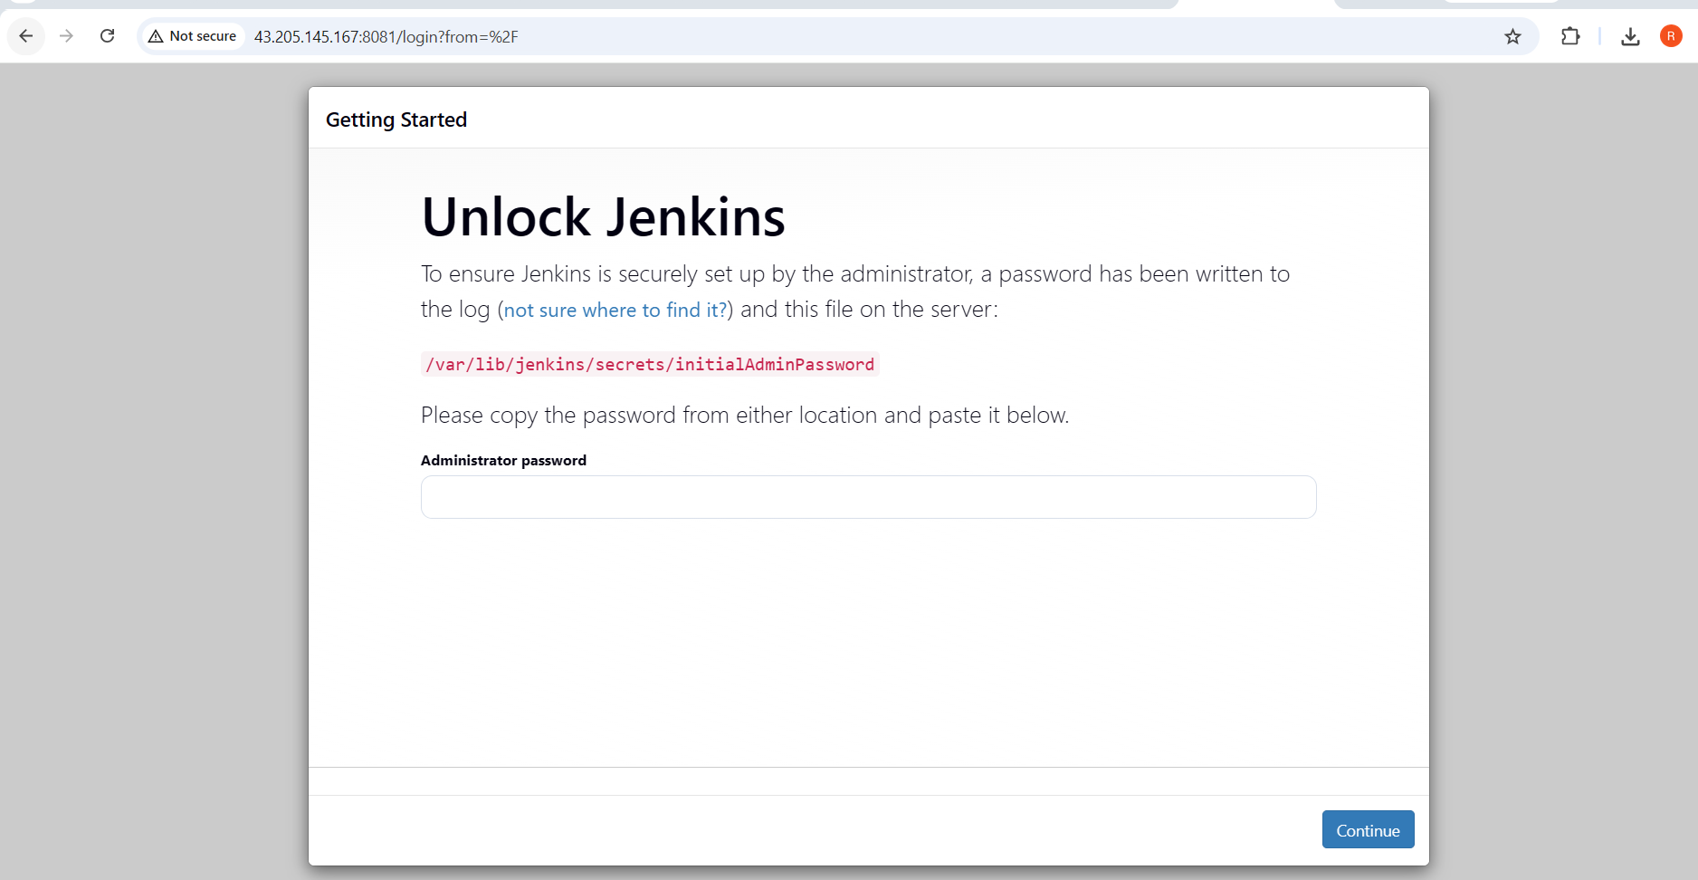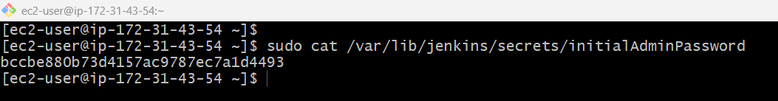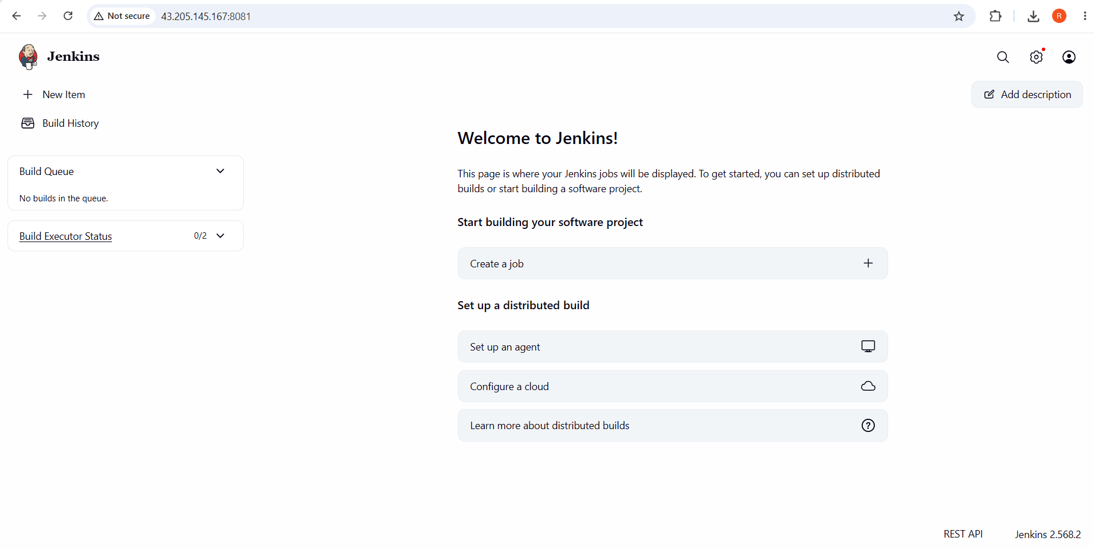

Install Apache.
Step 1: Connect to the EC2 Instance
- SSH into your running Amazon Linux 2 instance:
ssh -i my-ec2-key.pem ec2-user@<PUBLIC_IP>
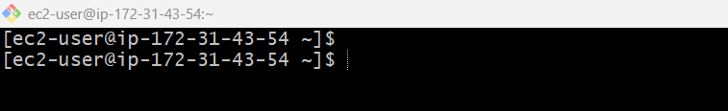
Step 2: Update System Packages
- Refresh package metadata and update existing packages:
sudo yum update -y
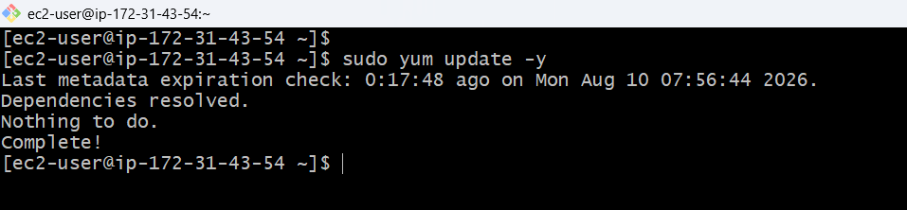
Step 3: Install Apache (httpd)
- On Amazon Linux 2, the Apache HTTP Server package is called httpd and is available directly from the default yum repo:
sudo yum install -y httpd
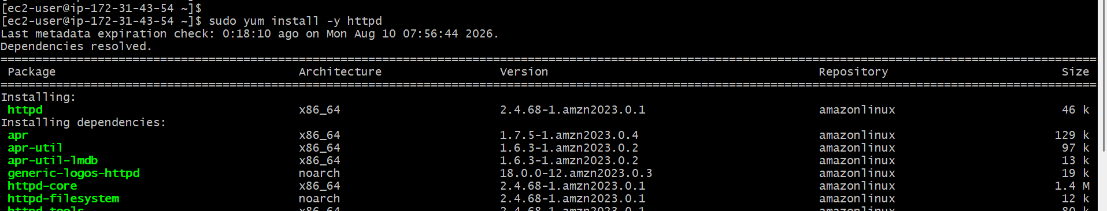
- This installs the Apache web server along with its default configuration files.
Step 4: Handle the Port Conflict with Nginx (Important)
- Apache listens on port 80 by default. If Nginx will also run on this same EC2 instance, it also defaults to port 80 — one of the two must be moved.
- Recommended: keep Nginx on port 80 and move Apache to port 8082. Edit the Listen directive in httpd.conf:
sudo sed -i 's/^Listen 80/Listen 8082/' /etc/httpd/conf/httpd.conf
- You can verify the change was applied:
grep '^Listen' /etc/httpd/conf/httpd.conf
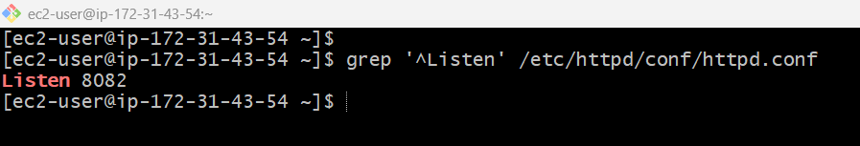
Step 5: Start and Enable the Apache Service
- Start Apache:
sudo systemctl start httpd
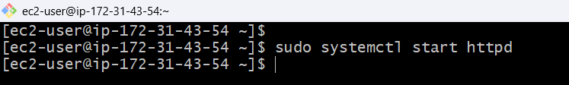
- Enable Apache to start automatically on system boot:
sudo systemctl enable httpd
- Check the service status:
sudo systemctl status httpd
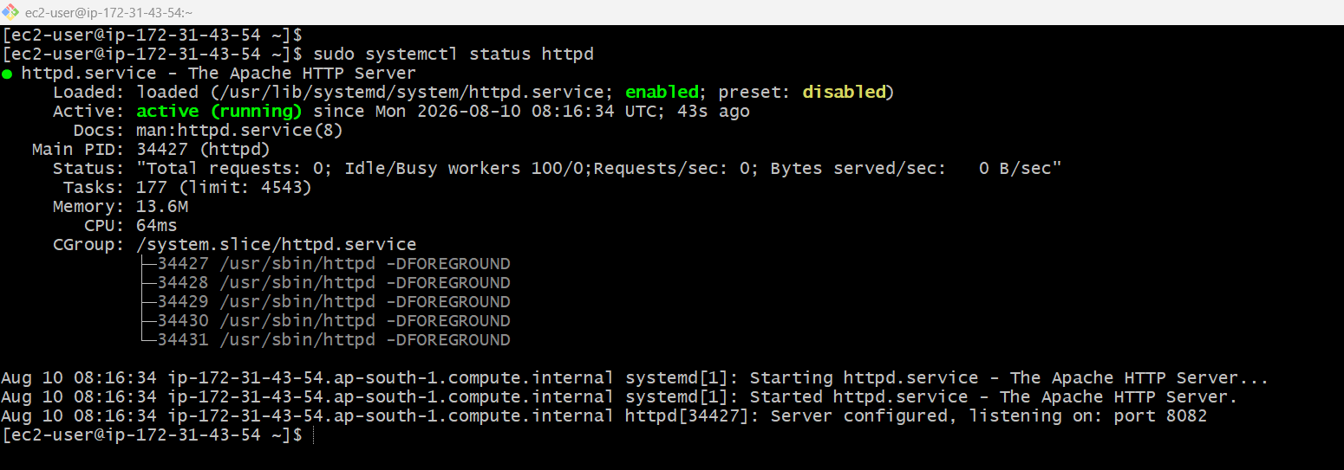
- Look for Active: active (running) in the output.
Step 6: Open the Required Port in the Security Group
- In the AWS Console, go to EC2 → Security Groups → select your instance's security group.
- Edit inbound rules and add:
  - Type: Custom TCP, Port: 8082 (or 80 if you didn't change it), Source: your IP or 0.0.0.0/0
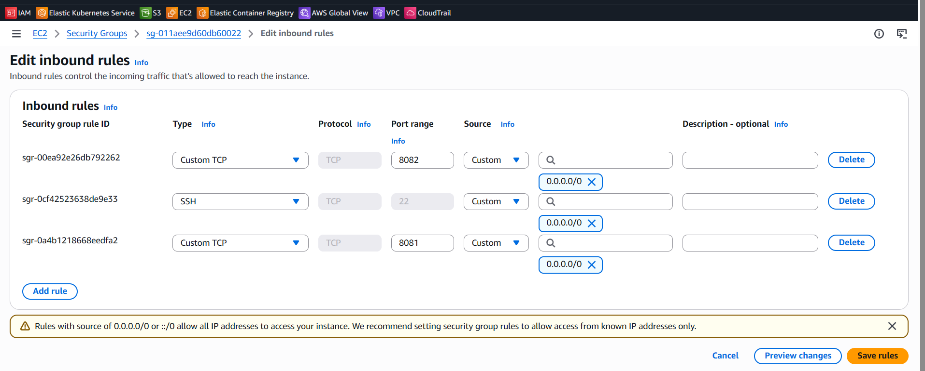
Step 7: Verify Apache Is Serving Pages
http://<PUBLIC_IP>:8082
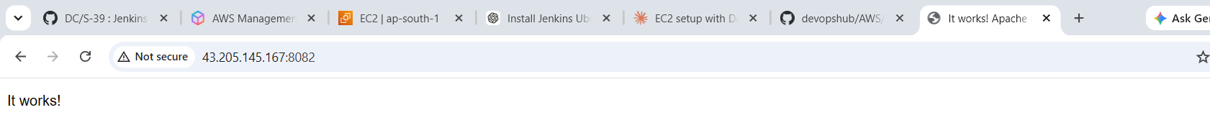
- You should see the Apache HTTP Server Test Page confirming a successful installation.
Step 8: (Optional) Replace the Default Page
- Apache serves files from /var/www/html by default. Create a simple custom index page to confirm you can publish your own content:
echo '<h1>Apache is running on this EC2 instance</h1>' | sudo tee /var/www/html/index.html
Refresh the browser at http://<PUBLIC_IP>:8082 to see the updated page.
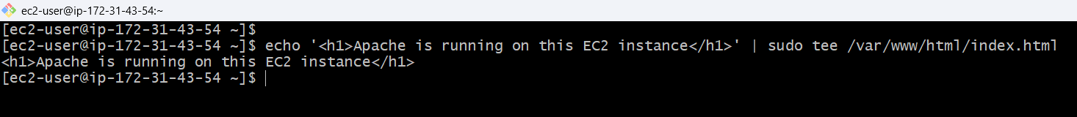 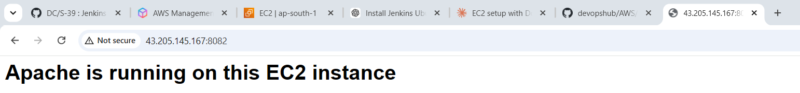
Install Nginx.
Step 1: Connect to the EC2 Instance
- SSH into your running Amazon Linux 2 instance:
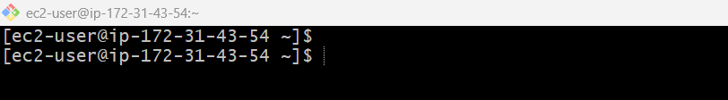
Step 2: Update System Packages
- Refresh package metadata and update existing packages:
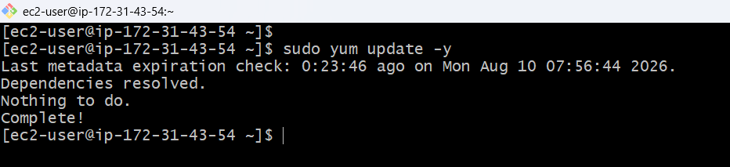
Step 3: Install Nginx
- Nginx isn't in the default Amazon Linux 2 yum repo — it's provided through the amazon-linux-extras repository, same as Docker:
sudo dnf install nginx -y
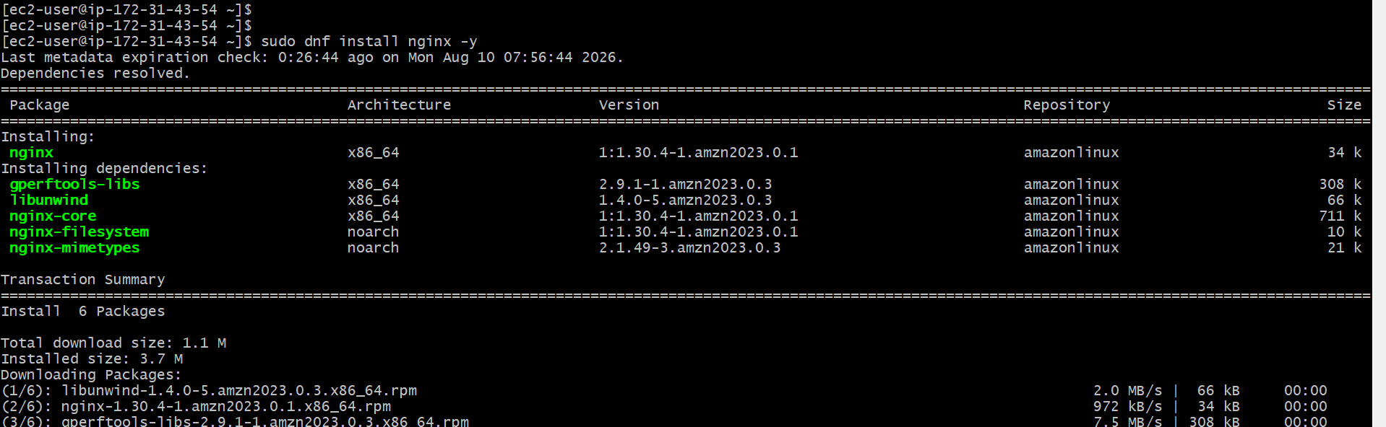
- This downloads and installs the Nginx web server along with its default configuration.

Step 4: Check for a Port Conflict with Apache
- Nginx listens on port 80 by default — the same default port as Apache (httpd).
- If you followed the Install Apache notes and already moved Apache to port 8082, Nginx can safely keep the default port 80. No changes are needed here.
- If Apache is still on port 80, stop and move it first (see Install Apache Notes, Step 4) before starting Nginx, otherwise Nginx will fail to bind to the port.
Step 5: Start and Enable the Nginx Service
- Start Nginx:
sudo systemctl start nginx
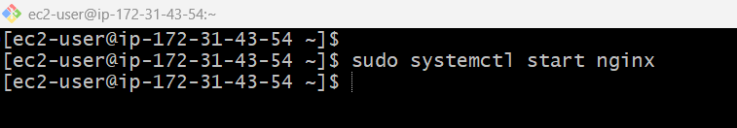
- Enable Nginx to start automatically on system boot:
sudo systemctl enable nginx
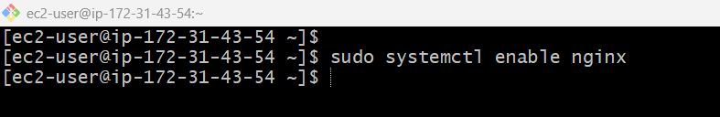
- Check the service status:
sudo systemctl status nginx
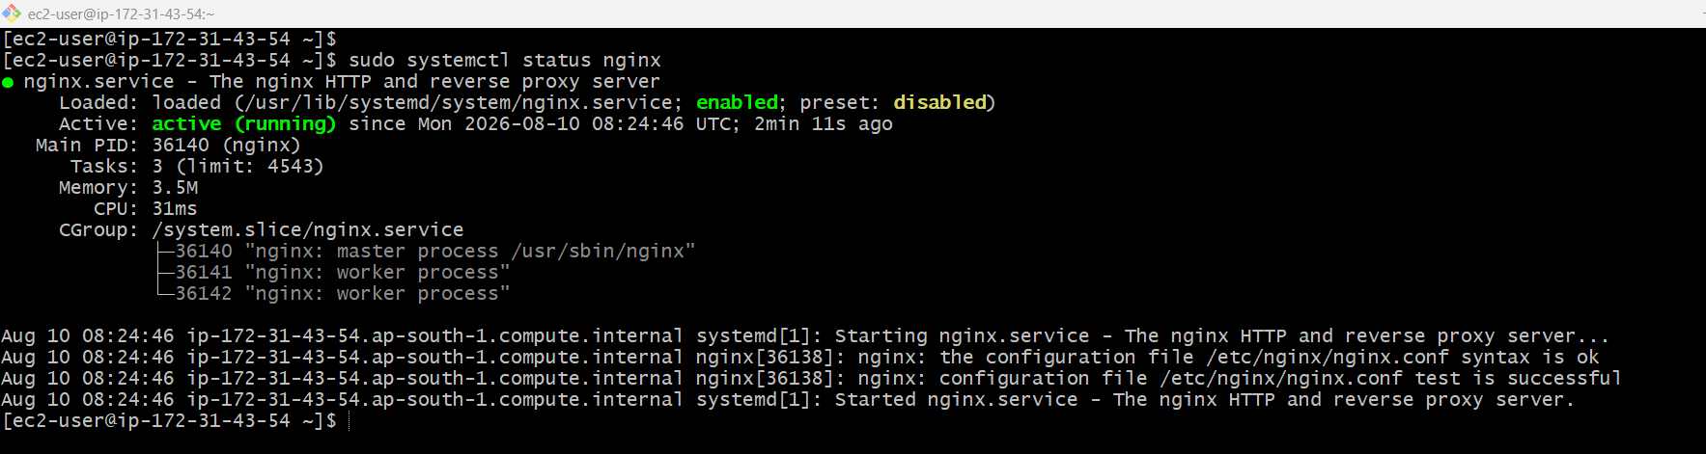
- Look for Active: active (running) in the output.
Step 6: Confirm the Security Group Allows Port 80
- In the AWS Console, go to EC2 → Security Groups → select your instance's security group.
- Confirm an inbound rule exists for:
  - Type: HTTP, Port: 80, Source: 0.0.0.0/0 (or your IP)
- Add it if it's missing — this rule was typically created in the Launch EC2 Instance step.
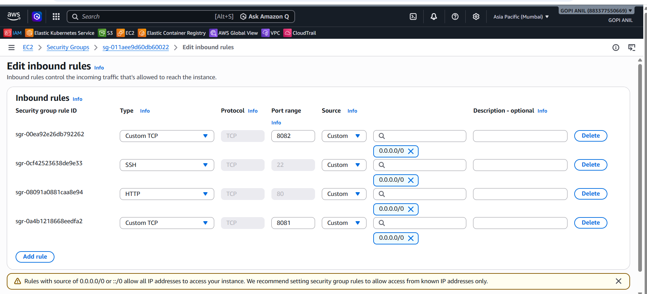
Step 7: Verify Nginx Is Serving Pages
- Test locally on the server first:
curl http://localhost
- You should see HTML output containing "Welcome to nginx!".
- From your browser, go to:
http://<PUBLIC_IP>
- You should see the default Nginx welcome page confirming a successful installation.
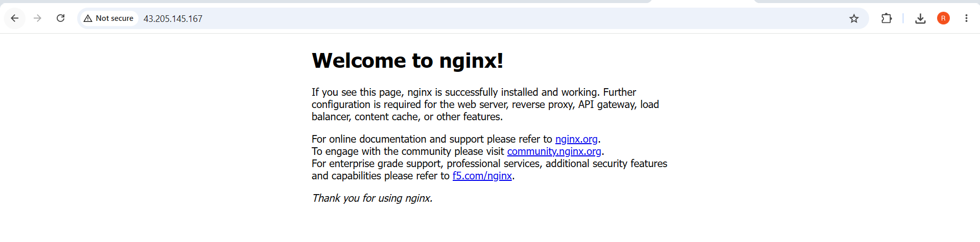
Step 8: (Optional) Replace the Default Page
- Nginx serves files from /usr/share/nginx/html by default. Create a simple custom index page:
echo '<h1>Nginx is running on this EC2 instance</h1>' | sudo tee /usr/share/nginx/html/index.html
- Refresh the browser at http://<PUBLIC_IP> to see the updated page.
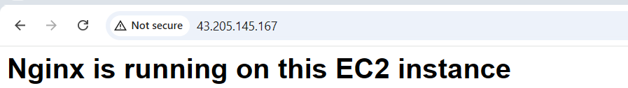
Install Apache Tomcat.
Step 1: Connect to the EC2 Instance
- SSH into your running Amazon Linux 2 instance: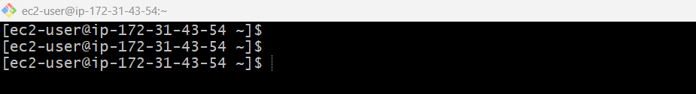
Step 2: Install Java
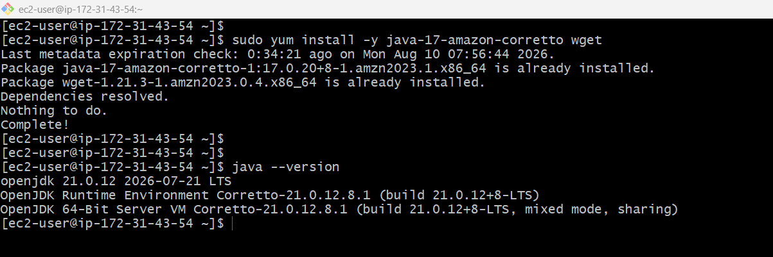
2. Create Tomcat user
sudo useradd -r -m -U -d /opt/tomcat -s /bin/false tomcat
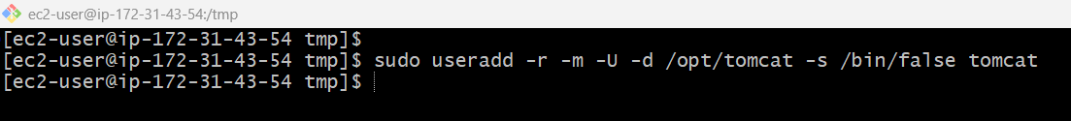
3. Download Tomcat
cd /tmp
wget https://dlcdn.apache.org/tomcat/tomcat-10/v10.1.57/bin/apache-tomcat-10.1.57.tar.gz
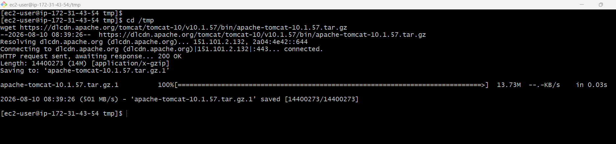
4. Install Tomcat
sudo mkdir -p /opt/tomcat
sudo tar -xzf apache-tomcat-10.1.57.tar.gz -C /opt/tomcat --strip-components=1
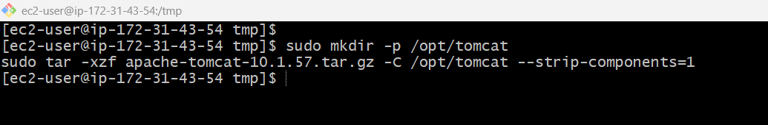
5. Set permissions
sudo chown -R tomcat:tomcat /opt/tomcat
sudo chmod +x /opt/tomcat/bin/*.sh
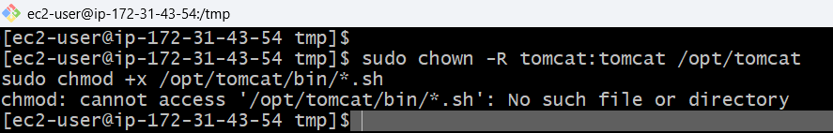
6. Create systemd service
sudo tee /etc/systemd/system/tomcat.service > /dev/null <<'EOF'
[Unit]
Description=Apache Tomcat
After=network.target

[Service]
Type=forking
User=tomcat
Group=tomcat

Environment="JAVA_HOME=/usr/lib/jvm/java-21-amazon-corretto"
Environment="CATALINA_HOME=/opt/tomcat"
Environment="CATALINA_BASE=/opt/tomcat"

ExecStart=/opt/tomcat/bin/startup.sh
ExecStop=/opt/tomcat/bin/shutdown.sh

Restart=on-failure

[Install]
WantedBy=multi-user.target
EOF
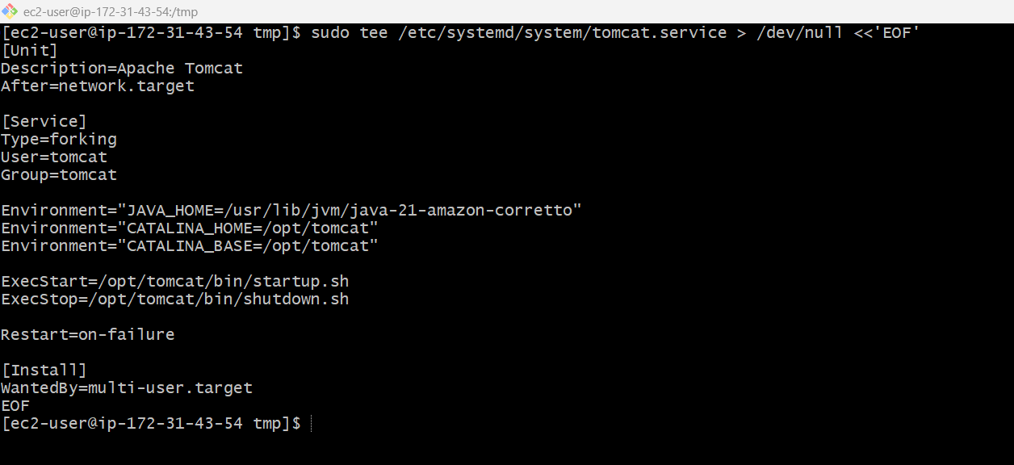
7. Start Tomcat
sudo systemctl daemon-reload
sudo systemctl enable --now tomcat
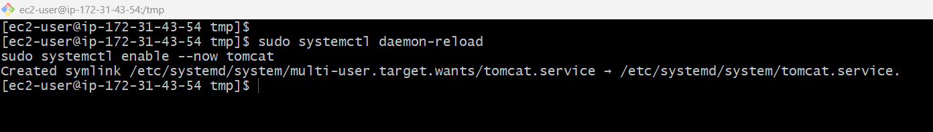
8. Check status
sudo systemctl status tomcat --no-pager
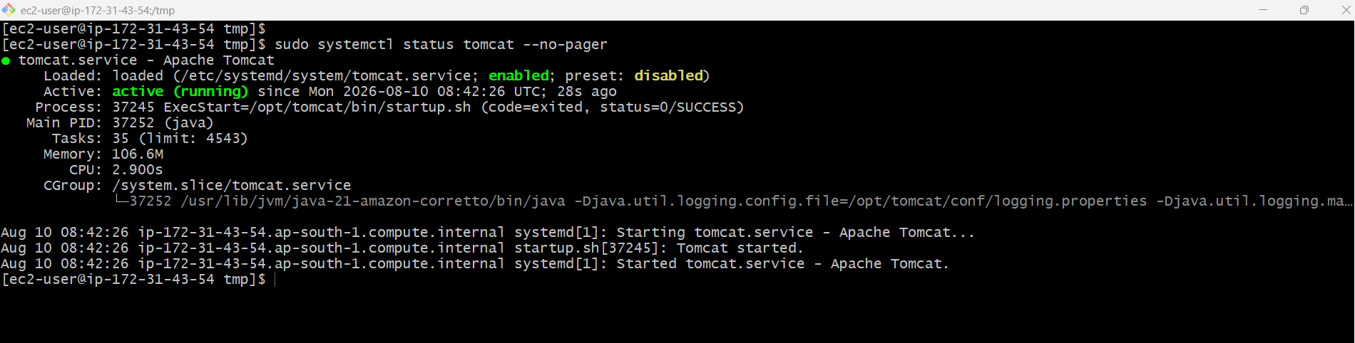
9. Check port 8080
sudo ss -lntp | grep 8080
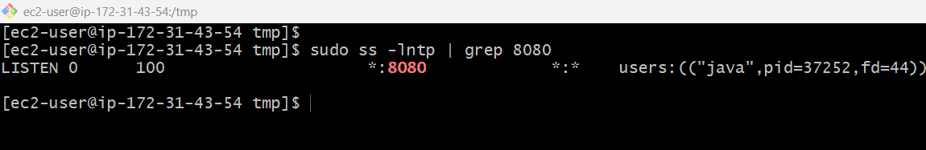
10. Open in browser
sudo sed -i 's/port="8080"/port="8082"/' /opt/tomcat/conf/server.xml
sudo systemctl restart tomcat
